**CENWP-OD-B 07/11/2023**

**MEMORANDUM FOR THE RECORD**

**SUBJECT: 23BON051 Bradford Island Pacific Lamprey Tube Trap Mortality**

On Tuesday afternoon 11 July 2023 CRITFC staff found one Pacific Lamprey mortality in one of the Bradford Island tube traps. The fish was collected at Bonneville Dam on 11 July for the CRITFC-Tribal translocation program. The cause of death is unknown, photos of the fresh mortality were taken at the time of removal from the trap and are attached. The individual was scanned for PIT tags and frozen for potential future pathogen evaluation.

1. Species – Pacific Lamprey (*Entosphenus tridentatus*)
2. Origin – unknown
3. Length – 68.6 cm
4. Marks and tags – none
5. Marks and Injuries found on carcass – none
6. Cause and Time of Death – unknown
7. Future and Preventative Measures – none

*.*

Sincerely,

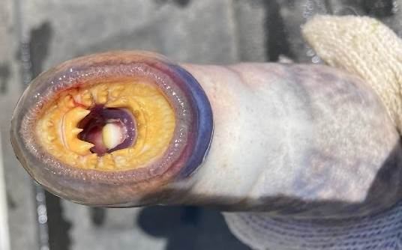

Project Fisheries

